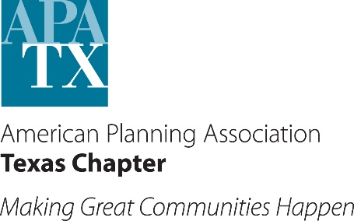
Central Texas
Elected & Appointed Officials Planning Workshop 2016
Presented by American Planning Association Texas Chapter
Hosted by Central Texas Council of Governments

WORKSHOP DESCRIPTION
The workshop will provide a full day forum specifically tailored to elected and appointed officials. The focus of this workshop is to provide training on the municipal planning process and present the latest issues for city council, board and commission members. Both new and experienced officials will benefit from this workshop. Planning professionals will present and discuss various planning and development related issues across Central Texas.

REGISTRATION FEE:
$35 Early Bird On-Line Registration ends June 21, 2016
$50 On-site Registration Check or Credit Card
WHEN:
Friday, June 24, 2016
9:00 a.m. - 4:00 p.m.
WHERE:
CTCOG Building
2180 N. Main Street
Belton, TX 76513

WORKSHOP AGENDA
Time | Topic | Trainer
9:00 to 9:30 AM | Check in and Refreshments
9:30 to 10:00 AM | Welcome and Introductions | Cheryl Maxwell, Director of Planning and Regional Services, CTCOG
10:00 to10:45 AM | The Job of the Planning Commissioner | Dave Gattis, FAICP, Deputy City Manager, City of Benbrook
10:45 to 11:00 AM | Break and Refreshments
11:00 to12:00 Noon | Basics of Planning and Development Review | Dave Gattis, FAICP, Deputy City Manager, City of Benbrook
12:00 to 1:30 PM | Lunch and Presentation: Current Trends and Hot Topics | Kim Mickelson, AICP, JD, Olson and Olson
1:30 to 2:15 PM | Role and Ethical Principles for Planning Commissioners | Ann Bagley, FAICP, Bagley Associates
2:15 to 2:30 PM | Break and Refreshments
2:30 to 3:15 PM | Basics of Zoning and Subdivision | Dave Gattis, FAICP, Deputy City Manager, City of Benbrook
3:15 to 3:45 PM | Board of Adjustments | Ann Bagley, FAICP, Bagley Associates
3:45 to 4:00 PM | Closing Remarks | Cheryl Maxwell, Director of Planning and Regional Services, CTCOG

QUESTIONS? Contact Mike McAnelly at administrator@apatexas.org or (214) 850-9046
ONLINE REGISTRATION (Click Here)
EARLY REGISTRATION DEADLINE MONDAY, JUNE 21, 2016

